Works from choreographers Donald Byrd, Tsai Hsi Hung, Joshua Blake Carter, Monique Haley, Terence Marling and Kia S. Smith
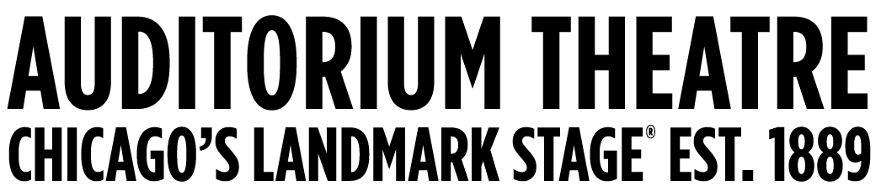
For Immediate Release
PHOTOS AVAILABLE HERE

The Auditorium Theatre Proudly Presents
South Chicago Dance Theatre in New Horizons
One night only, April 27 at 7:30 p.m.

Program includes six world premiere performances commissioned by renowned choreographers: by local, national and international choreographers Donald Byrd, Tsai Hsi Hung, Joshua Blake Carter, Monique Haley, Terence Marling and South Chicago Dance Theatre Executive Artistic Director Kia S. Smith

March 18, 2023 (CHICAGO) – The Auditorium Theatre (Chicago’s landmark stage at 50 E. Ida B. Wells Drive) proudly presents South Chicago Dance Theatre (SCDT)—a Chicago based, internationally toured, multi-cultural dance company—in a one-night-only performance Saturday, April 27 at 7:30 p.m. as part of the theatre’s Made In Chicago Dance Series. Tickets are $33–$85 and are available at auditoriumtheatre.org.

Returning to the Auditorium Theatre after last year’s critically acclaimed world-premiere performance of Memoirs of Jazz in the Alley and closing out a blockbuster 7th season that included the company’s first tour to South America, SCDT will bring its signature dynamic, high-energy, performance style back to the Auditorium stage with six company-commissioned world premieres in a program aptly named New Horizons. Touching on themes of emerging from darkness into light and bringing people together, the diverse program features works by six top contemporary choreographers Donald Byrd, Joshua Blake Carter, Monique Haley, Tsai Hsi Hung, and Terence Marling, alongside a new title by SCDT Founder and Executive Artistic Director Kia S. Smith.

The program includes:
- IT BEGINS by one of the most well-known names in contemporary choreography Donald Byrd. Byrd’s numerous career highlights include choreographing the original Broadway production of The Color Purple. The sound design for IT BEGINS is by Rob Whitmer.

- Under the Skin, a contemporary work choreographed by New York and Taiwan-based Tsai Hsi Hung, moves slowly from darkness into light. Under the Skin is set to an experimental new score by Taiwanese musician Yi Chun Hung.

- Soul Power, a work by Chicago-based Monique Haley that explores the origins African dance traditions that form the basis for American jazz dance. Originally choreographed during the early days of the pandemic, Haley has reworked the piece from its socially-distant premiere specifically for the Auditorium stage.

- An Opening, by Chicago based Terence Marling, taps into the power of House Music and street dance as the piece moves over time from a proletariat to a contemporary feel. An Opening will be accompanied live on stage by pianist Emily Barret.

- Of Silence, choreographed by Kia S. Smith, is based in the contemporary idiom. Set to the iconic movement “Winter” from Vivaldi’s Four Seasons, Of Silence explores Smith’s personal aesthetic as a burgeoning choreographer.

- Closing out the program is Infinity Engine by Chicago’s own Joshua Blake Carter. Commissioned by SCDT as a finale, Infinity Engine is an impressive display of explosive athleticism that will leave audiences in awe. The work is set to three pieces of music by Jin (ft. Philip Glass), Jerskin Fendrix, and Trentmøller.

“Our seventh season has been our best season yet,” said Smith. “The South Chicago Dance Theatre dancers are in top form, and we are excited to share our progress with our home audiences on the iconic stage of the Auditorium Theatre. New Horizons represents a new artistic phase in SCDT’s trajectory. We are thrilled to be able to bring new works from some of the top choreographers working today to our home stages.”

“Auditorium Theatre audiences loved South Chicago Dance Theatre’s world premiere of Memoires of Jazz in the Alley,” says Auditorium Theatre CEO Rich Regan. “We are glad to bring SCDT back to our stages. Chicago has such a vibrant dance scene, and we are privileged to present this gem of the South Side once again.”

About South Chicago Dance Theatre
Since its 2017 launch, the Main Company has toured regionally, nationally, and internationally, and has commissioned the choreographic work of renowned artists. Its collaborative initiatives have included music ensembles, television, opera, art museums, and public schools through a range of self-produced and institutionally presented performances. Prioritizing intergenerational learning and exchange, SCDT’s seven core include the Main Company and Emerging Artist Program, the Choreographic Fellowship, the Education and Community Programs, the South Chicago Arts Administration Fellowship, the annual South Chicago Dance Festival, and the Choreographic Diplomacy Program. The art of dance empowers our community to resist oppression and foster collective healing. For information, visit southchicagodancetheatre.com.

About The Auditorium Theatre
The Auditorium Theatre, located at 50 E. Ida B. Wells Drive in Chicago, is an Illinois not-for-profit organization committed to presenting the finest in international, cultural, community, and educational programming to all of Chicago and beyond as The Theatre for the People. The organization also is committed to the continued restoration and preservation of this National Historic Landmark that originally opened in 1889.

The Auditorium Theatre is grateful for the support of the 2023-24 Season Global and Made In Chicago Dance Series Sponsor: The Florian Fund, Made In Chicago Dance Series sponsors: Joyce Chelberg, Pamela Crutchfield, and Patti Eylar and Charlie Gardner. The Auditorium Theatre 2023-24 Season is made possible in part by support from the John D. and Catherine T. MacArthur Foundation, Department of Cultural Affairs and Special Events, and the Illinois Arts Council Agency. The Auditorium’s official hotel partner is the Palmer House Hilton.

This Auditorium Theatre’s 2023-24 performance season features a dynamic mix of cultural events from ballet to rock and roll and everything in between. For more information on the Auditorium Theatre and a complete listing of events at the Auditorium Theatre, please visit AuditoriumTheatre.org.

###

MEDIA CONTACT FOR AUDITORIUM THEATRE
Alannah Spencer/ Beth Silverman
The Silverman Group, Inc.
Alannah@silvermangroupchicago.com
Beth@silvermangroupchicago.com
608-692-4778 (m)

