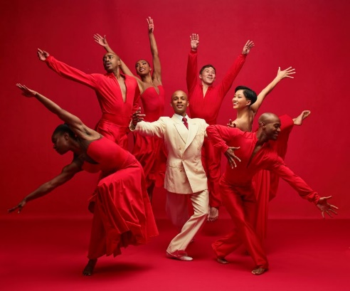 | 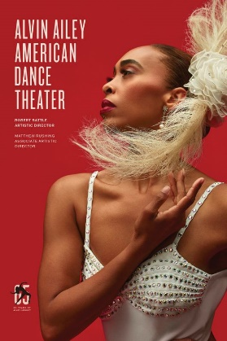 | 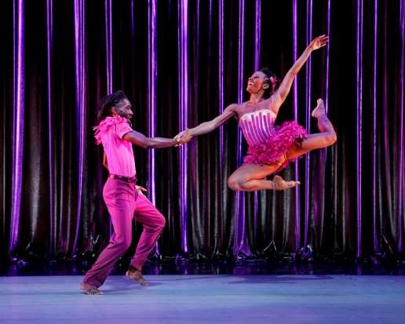
Photo Credits (L to R): Members of the Company in Alvin Ailey's For 'Bird' - With Love. Photo by Dario Calmese; 2023-2024 Season Image. Photo by Dario Calmese; Alvin Ailey American Dance Theater’s Chalvar Monteiro and Jacquelin Harris in Amy Hall Garner’s CENTURY. Photo by Paul Kolnik.Click on photos for high-res download.

For Immediate Release
PHOTOS AVAILABLE HERE

Auditorium Theatre announces programming for highly anticipated return of
ALVIN AILEY AMERICAN DANCE THEATER in six performances only,
April 17-21, 2024

World-renowned ambassadors of Dance and Culture make 55th visit
to Auditorium Theatre in 2024.

Celebrating its 65th Anniversary Season, company to perform three unique programs: AUDIENCE FAVORITES, AILEY CLASSICS, and ALL-NEW AILEY,
featuring pair of Midwest Premieres!
*Tickets now on sale*

February 20, 2024 (CHICAGO) – World renowned ambassadors of Dance and Culture, the Alvin Ailey American Dance Theater returns to its Chicago home – the landmark Auditorium Theatre at 50 E. Ida B. Wells Drive – for its 55th engagement here, with six dynamic performances, April 17-21, 2024. Celebrating its 65th Anniversary season in 2023-24, the company will perform three distinct programs certain to appeal to both longtime Ailey fans and new audiences discovering this joyous company for the first time: AUDIENCE FAVORITES, ALL-NEW, and AILEY CLASSICS. Tickets, starting at $40, are now on sale at Alvin Ailey American Dance Theater | Auditorium Theatre.

In 1958, Alvin Ailey and a small group of young Black modern dancers took the stage in New York City and forever changed the perception of American dance and culture. One of the country’s groundbreaking greats, Alvin Ailey American Dance Theater is recognized by US Congressional resolution as a vital American “Cultural Ambassador to the World”, promoting the uniqueness of the African American cultural experience and the preservation and enrichment of American modern dance in a universal celebration of the human spirit.

Led by Associate Artistic Director Matthew Rushing, the acclaimed Ailey dancers will showcase their passionate spirit and extraordinary technique in three specially themed programs. AUDIENCE FAVORITES features Kyle Abraham’s critically applauded Are You In Your Feelings? and a new production of Ronald K. Brown’s tribute to Judith Jamison’s profound influence Dancing Spirit, along with the Company’s traditional program closer, Alvin Ailey’s beloved must-see masterpiece Revelations. ALL-NEW presents a pair of exciting new works commissioned especially for Ailey: Amy Hall Garner’s rousing, high spirited tribute to her grandfather, CENTURY; and Elizabeth Roxas-Dobrish’s dreamlike duet reminiscence of romance, Me, Myself and You; in addition to updated productions of the audacious Following the Subtle Current Upstream by Alonzo King and the tour de force Solo by Hans van Manen. AILEY CLASSICS offers a newly curated two-act program sampling a variety of classic works by Alvin Ailey culminating with his signature Revelations.

“Alvin Ailey American Dance Theater’s annual engagement at the Auditorium Theatre is a recognized highlight of the Spring arts season, and we’re pleased to be able to announce the exceptional program lineup so far in advance to help the Company’s legion of Midwest fans plan their schedules,” said Auditorium Theatre CEO Rich Regan. “We look forward to welcoming back the Company led by Matthew Rushing, with whom we’ve had the pleasure to work for much of his 30 years with Ailey, with a diverse program for Chicago audiences.”

“We’re excited to return to our Chicago home with Ailey’s 65th Anniversary season featuring new works by exciting choreographic voices, along with a special program of classics by our legendary founder Alvin Ailey,” said Associate Artistic Director Matthew Rushing. “I share the audience’s excitement in watching the Company’s extraordinary dancers, some of whom hail from the area, share their artistry on the Auditorium stage to carry on a cherished legacy of inspiration.”

2024 AUDITORIUM THEATRE PROGRAM

AUDIENCE FAVORITES (Program A)

- A new production of Ronald K. Brown’s Dancing Spirit (2009), set to music by Duke Ellington, Wynton Marsalis, and War, which pays tribute to the women of Ailey by evoking the elegance, dignity, and generosity of Judith Jamison and borrowing the title of her autobiography.

- Are You in Your Feelings? (2022) In his third commission for the Ailey company, Kyle Abraham’s newest work is a celebration of Black culture, Black music, and the youthful spirit that perseveres in us all. Scored to a “mixtape” of soul, hip-hop, and R&B, it explores the connections among music, communication, and personal memory.

- Alvin Ailey’s American masterpiece, Revelations (1960) has been seen by more people than any other modern dance work and has moved audiences around the world through its powerful storytelling and soul-stirring music, evoking timeless themes of determination, hope, and transcendence. Springing from Ailey’s childhood memories of growing up in the south and attending services at Mount Olive Baptist Church in Texas, Revelations pays homage to the rich cultural heritage of the African American and explores the emotional spectrum of the human condition.

AUDIENCE FAVORITES will be performed Opening Night, Wednesday, April 17, at 7:30pm, and Saturday evening, April 20, at 7:30pm.

ALL-NEW (Program B)

- Amy Hall Garner launches her residency with her first work for the Company entitled CENTURY (2023), a deeply personal piece inspired by her grandfather on the eve of his 100th birthday. Taking a cue from his spirited essence and set to the music of Ray Charles, Count Basie, The Dirty Dozen Brass Band, and more, CENTURY is a celebration of life, resilience, and joy.

- Former Ailey dancer Elizabeth Roxas-Dobrish premieres a new duet titled Me, Myself and You (2023). A dreamlike dance about reminiscence, it is set to Damien Sneed and Brandie Sutton’s rendition of “In A Sentimental Mood,” conjuring the memories of love and passion for a woman who is asking herself if she should let go or forge ahead.

- Described by choreographer Alonzo King as “a piece about how to return to joy,” a new production of Following the Subtle Current Upstream (2000) mirrors life’s boisterous waves and reminds us that everything in nature seeks to return to its source. King’s movement -- abstract but steeped in meaning -- sets the dancers in constant flow to an eclectic score by Zakir Hussain, Miguel Frasconi, and Miriam Makeba.

- A new production of Hans van Manen’s Solo (1997), a tour de force among three dancers that challenges the Ailey men’s daring agility and grace. An explosive display of virtuosity and wit launches the performers into an exhilarating whirlwind of movement and musicality.

ALL-NEW will be performed Friday, April 19, at 7:30pm, and Saturday, April 20, at 1pm.

AILEY CLASSICS (Program C)

This special two-act Ailey Classics program is comprised of excerpts from some of Alvin Ailey’s beloved 20th century ballets including Memoria (1979), Night Creature (1974), Pas de Duke (1976), Masekela Langage (1969), Opus McShann (1988), Love Songs (1972), Reflections in D (1962) and For ‘Bird’ – With Love (1985). In Act 1 Memoria honors the life of a cherished friend and Night Creature fuses Ailey’s buoyant choreography with Duke Ellington’s sparkling music. Act II features the strong yet serene solo Reflections in D along with highlights from the spirited duet Pas de Duke, the commanding choreography in Masekela Langage, the comical meandering of Opus McShann, the lyrical solo from Love Songs, and the magical Charlie Parker tribute For ‘Bird’ – with Love. Ailey’s American signature masterpiece, Revelations, concludes the program.

AILEY CLASSICS will be performed Thursday, April 18, at 7:30pm, and Sunday, April 21 at 3pm.

PERFORMANCE SCHEDULE AND TICKETS

Alvin Ailey American Dance Theater performs at the Auditorium Theatre: Wednesday, April 17 at 7:30pm; Thursday and Friday, April 18-19 at 7:30pm; Saturday, April 20 at 1pm and 7:30pm; and Sunday, April 21 at 3pm. Tickets start at $40 and are now available at AuditoriumTheatre.org, by calling 312.341.2300, or at the Box Office at 50 E Ida B Wells Drive in Chicago, IL. Click here for phone and in-person hours.

Discounted tickets for groups of 10 or more people are available. The Auditorium Theatre offers $20 student rush tickets to full-time college students and a Student Savings Club for both college and high school students. Click here for more information on discounted tickets.

About Alvin Ailey American Dance Theater
Alvin Ailey American Dance Theater, recognized by U.S. Congressional resolution as a vital American “Cultural Ambassador to the World,” grew from a now‐fabled March 1958 performance in New York that changed forever the perception of American dance. Founded by Alvin Ailey, posthumous recipient of the Presidential Medal of Freedom—the nation’s highest civilian honor, and guided by Judith Jamison beginning in 1989, the Company was then led by Robert Battle from 2011 to 2023. Alvin Ailey American Dance Theater has performed for an estimated 25 million people in 71 countries on six continents, promoting the uniqueness of the African American cultural experience and the preservation and enrichment of the American modern dance tradition. In addition to being the Principal Dance Company of New York City Center, where its performances have become a year‐end tradition, the Ailey company performs annually at the John F. Kennedy Center for the Performing Arts in Washington, DC, the Auditorium Theatre in Chicago, The Fox Theatre in Atlanta, Zellerbach Hall in Berkeley, CA, and at the New Jersey Performing Arts Center in Newark (where it is the Principal Resident Affiliate), and appears frequently in other major theaters throughout the world during extensive tours. The Ailey organization also includes Ailey II (1974), a second performing company of emerging young dancers and innovative choreographers; The Ailey School (1969), one of the most extensive dance training programs in the world; Ailey Arts In Education & Community Programs, which brings dance into the classrooms, communities, and lives of people of all ages; and The Ailey Extension (2005), a program offering dance and fitness classes to the general public, which began with the opening of Ailey’s permanent home—the largest building dedicated to dance in New York City, the dance capital of the world—named The Joan Weill Center for Dance, at 55th Street at 9th Avenue in New York City. For more information, visit www.alvinailey.org.

About The Auditorium Theatre
The Auditorium Theatre, located at 50 E. Ida B. Wells Drive at Roosevelt University in Chicago, is an Illinois not-for-profit organization committed to presenting the finest in international, cultural, community, and educational programming to all of Chicago and beyond as The Theatre for the People. The organization also is committed to the continued restoration and preservation of this National Historic Landmark that originally opened in 1889.

The Auditorium Theatre is grateful for the support of our 2023-24 Season Global and Made in Chicago Dance Series Sponsor: The Florian Fund; our Student Matinee Series Sponsors: Deborah and Bruch Crown, Denise Littlefield Sobel, and The Robert Thomas Bobins Foundation; our Alvin Ailey American Dance Theater Production Sponsor: Denise Littlefield Sobel; and our Ailey Opening Night Sponsor: Helen Hall Melchior. The Auditorium Theatre 2023-24 Season is made possible in part by support from the John D. and Catherine T. MacArthur Foundation, the City of Chicago Department of Cultural Affairs and Special Events, and the Illinois Arts Council Agency. The Auditorium’s official hotel partner is the Palmer House, a Hilton Hotel.

This Auditorium Theatre’s 2023-24 performance season features a dynamic mix of cultural events from ballet to rock and roll and everything in between. For more information on the Auditorium Theatre and a complete listing of events at the Auditorium Theatre, please visit AuditoriumTheatre.org.

###

MEDIA CONTACTS:
Beth Silverman/Alannah Spencer
The Silverman Group, Inc.
Beth@silvermangroupchicago.com
312-560-4783 (m)

