For Immediate Release
Assets Available HERE

ON STAGE THIS SUMMER AT THE
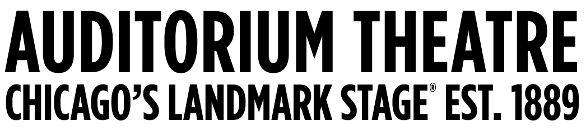

(March 26, 2024) This summer, the not-for-profit Auditorium Theatre (50 E. Ida B. Wells Drive) dedicated to presenting the finest in international, cultural, community, and educational programming to all of Chicago and beyond as The Theatre for the People, is the place to be. The organization is also committed to the continued restoration and preservation of this National Historic Landmark that originally opened in 1889. Among offerings on the Auditorium Theatre stage in Summer 2024 (as of mid-March):

SUMMER SPOTLIGHT:
Marvel Studios’ Black Panther in Concert
Saturday, June 22 at 7:30 PM

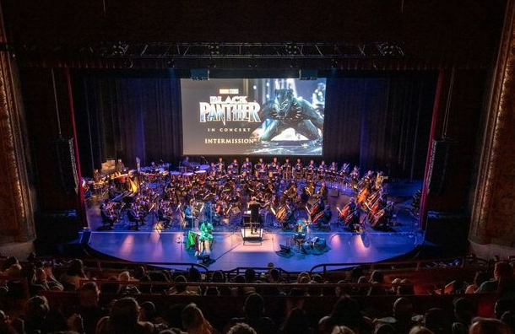
After an electric sold-out debut in 2022, Chicago Philharmonic brings back Marvel Studios’ Black Panther in Concert. In 2018, Marvel Studios’ “Black Panther” quickly became a global sensation and cultural phenomenon, showing a new dimension of what Superhero films could be.
Relive the excitement of T’Challa becoming king and battling Killmonger all while the Chicago Philharmonic performs Ludwig Göransson’s Oscar® and Grammy®-winning score live to picture. Joining the orchestra for the concert is Massamba Diop, the revered Senegalese tama drummer who recorded and co-created parts of the movie score with composer Göransson. Black Panther in Concert is part of the inaugural season of the Auditorium Philms Concert Series. Single tickets start at $69.00 with discounted subscriptions available.

ADDITIONAL PROGRAMMING IN SUMMER 2024:

Good Mythical Tour with Rhett & Link
Saturday, June 1 at 7:30PM
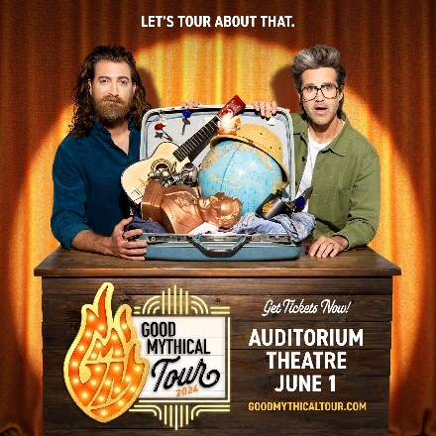
Good Mythical Morning is going on tour for the first time ever! Join Rhett & Link and the Mythical Crew live and in-person for a night that will bring the show you love to life like you’ve never experienced it before. Featuring your favorite segments, classic games, music, mayhem, Mythicality and more. You may even become part of the show. Tickets are currently sold out for this show.

Tye Tribbett and Friends: Only One Night Tho
Thursday, June 6 at 7:30 PM
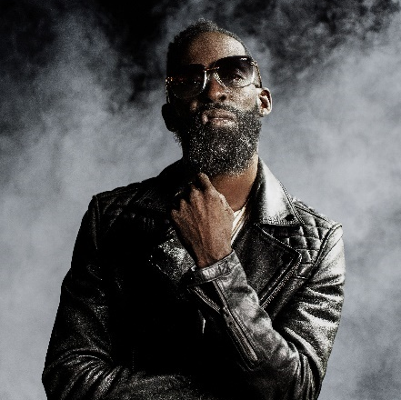
Tye Tribbett has had a legendary career and his saga has stayed on that trajectory these past two years culminating most recently having earned the 2024 Best Gospel Album GRAMMY Award for his release of All Things New: Live In Orlando. This momentous news marked the second time he has won the award and brings his career total wins to three. He is globally known for his charismatic, dynamic personality, and range – from delivering high-energy praise songs to intimate worship moments and even African rhythms to trap beats. His music cannot be classified as just one genre, but his unique, abstract way encompasses all, which has helped him garner many awards and accolades, including now three GRAMMY® wins (and now thirteen GRAMMY® nominations), six #1 albums, four #1 digital tracks, five #1 radio singles, and eleven Billboard Top 10 songs. Tickets start at $35.50.

Amos Lee | Transmissions Tour | with Mutlu
Friday, June 21 at 7:30PM
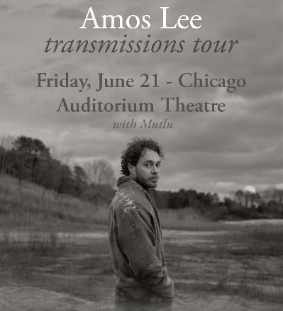
On his eleventh studio album, Transmissions, singer-songwriter Amos Lee continues to expand his sonic range while sharpening his closely observed lyrics that squarely address death, aging, and love. The force behind such acclaimed albums as Mission Bell and Mountains of Sorrow, Rivers of Song, ever since his gold-selling 2005 debut Lee has been known for his association with a long list of collaborators and touring partners, from Paul Simon to Zac Brown Band. Tickets start at $55.50.

Future Islands
Friday, June 28 at 7:30PM
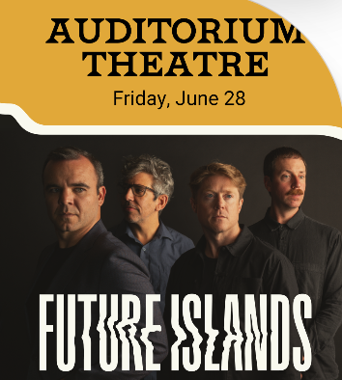
From their start, Future Islands have been singular and instantly identifiable. Samuel T. Herring’s life-worn croons and cries backlit by Gerrit Welmers’ melodies and charged by the rhythms of William Cashion and Michael Lowry. There’s a pain and a joy in Herring’s voice that’s only been rivaled by their legendary live performances. Future Islands have played nearly 1,500 shows – shows that have bruised bodies, frayed vocal cords, provided escapes for audiences, and healed their messengers. Tickets start at $33.50.

Heroes: A Video Game Symphony
Saturday, July 13 at 7:30PM
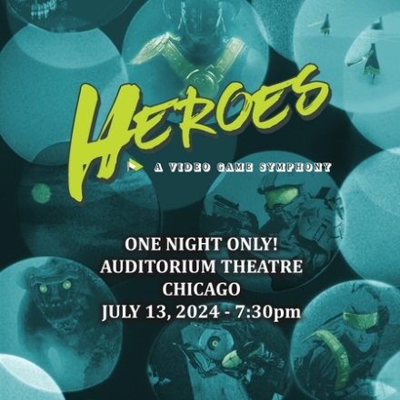
What’s a hero’s journey without appropriately heroic music to accompany it? Heroes: A Video Game Symphony features a live orchestra performing music from epic video games such as Castlevania, Metal Gear Solid, Starfield, The Elder Scrolls, Fallout, God of War, Mass Effect, Final Fantasy, Journey, Portal 2 and The Last of Us with scenes from the games projected onto a huge screen. Step away from the console and step into a new sensory take on video games. Tickets start at $45.00

Stuff You Should Know
Wednesday, August 7 at 7:00PM
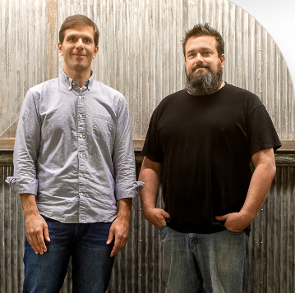
Stuff You Should Know is the award-winning podcast hosted by Chuck Bryant and Josh Clark and produced by the venerable website HowStuffWorks. Twice weekly since 2008, Stuff You Should Know has released a mind-addling array of episodes, cracking open the mechanics, history and cultural and scientific impact of topics like: Ouija boards, asteroid mining, termites, the use of MDMA to treat mental illness, the game of horseshoes, gender reassignment surgery, what would happen if the Earth stopped spinning, Barbie(r) dolls, peak oil, the effects of going without sleep, bioluminescence, disco, icebergs, the fat tax and so on and so on, totaling more than 800 episodes and adding two more every Tuesday and Thursday. So far, SYSK has had over 15 BILLION downloads by listeners around the world. Tickets start at $36.00.

ONGOING THEATRE TOURS
The public is invited year-round to take exclusive behind-the-scenes tours to learn about the secrets and stories that make the Auditorium Theatre unique! Explore this national historic landmark designed by famed architects Louis Sullivan and Dankmar Adler like never before. Be awed by taking a closer look at the brilliant 24-karat gold-leafed ceiling arches and the beautifully restored artwork throughout the building. Tours are approximately 80-90 minutes in length and take place Mondays, Wednesdays, and Saturdays at noon. For a reservation, please contact 312.341.2300.
Tickets for all events are now on sale, with more performance dates to be announced! For more information or to purchase tickets, please visit AuditoriumTheatre.org.
###

Media contact:
Alannah Spencer/Beth Silverman
The Silverman Group, Inc.
Alannah@silvermangroupchicago.com
Beth@silvermangroupchicago.com
608-692-4778 (cell)/ 312-560-4783 (cell)

