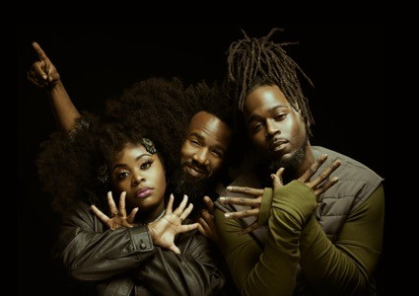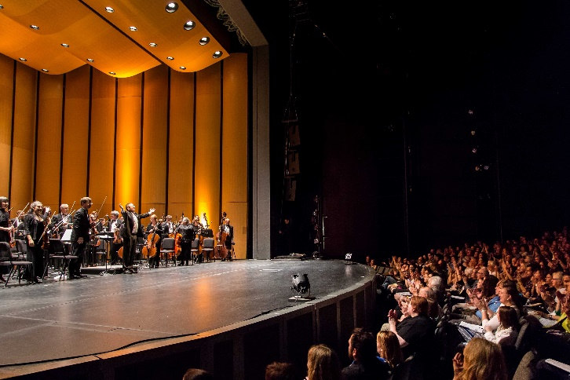
photo credit: Jeremy Tauriac

For Immediate Release
Photos Available HERE

The Auditorium Theatre Proudly Presents
Tank and The Bangas with Chicago Philharmonic
One Night Only: Saturday, September 30, 2023

Featuring brand new arrangements of two hit Tank and The Bangas songs: “Black Folks” and “Jellyfish” from GRAMMY-nominated album Red Balloon

August 24, 2023 (CHICAGO) – The Auditorium Theatre (Chicago’s landmark stage at 50 E Ida B. Wells Drive) is proud to present genre-defying hit band Tank and The Bangas performing with Chicago’s own Chicago Philharmonic one night only Saturday September 30, 2023 at 7:30 PM.
GRAMMY-nominated in 2020 as “Best New Artist” and in 2022 for “Best Progressive R&B Album,” New Orleans-based Tank and The Bangas are quickly gaining wide acclaim with an incredibly uncategorical and soulful mixture of R&B, hip-hop and spoken-word fused into an energetic live performance. Led by the incomparable Tarriona “Tank” Ball, Tank and The Bangas is joined by Chicago Philharmonic under the direction of Artistic Director Scott Speck to newly unleash their music as a massive orchestral concert experience at the Auditorium. Notably, Chicago Philharmonic will debut new arrangements of two Tank and The Banga favorites: "Black Folk" and "Jellyfish" (both from the band's GRAMMY-nominated 2022 album Red Balloon and arranged by Michael Moricz.)

"At Chicago Philharmonic, we take great pride in using every concert as an opportunity to break genre boundaries and change audience perceptions on what a symphony orchestra can be.” said Chicago Philharmonic Executive Director Terell Johnson. " Just like us, Tank and The Bangas are invested in producing great music, and subverting genre expectations. We are thrilled to perform alongside the incredibly talented band, at a venue as special as the Auditorium Theatre, Chicago’s theater for the people.”

About Tank and The Bangas
New Orleans-based Tank and The Bangas rose to prominence in 2017 following their unanimous NPR Music Tiny Desk Contest victory. In 2019, the band released its major label debut, Green Balloon, on Verve Forecast to widespread critical praise. Throughout their career, the group has performed on “The Tonight Show Starring Jimmy Fallon,” “Austin City Limits” and “The Today Show.” Tank and The Bangas have toured non-stop, selling out venues both stateside and abroad including festival appearances at Coachella, Glastonbury, Bonnaroo, and the Newport Jazz Festival. Most recently, the band’s third studio album, Red Balloon, received a nomination for “Best Progressive R&B Album” at the 2023 GRAMMY Awards. This milestone follows the band’s “Best New Artist” nomination in 2020.

Tank and The Bangas are Tarriona “Tank” Ball (lead vocals), Joshua Johnson (drums) and Norman Spence (keys).

About The Chicago Philharmonic Society

Founded by musicians of the Lyric Opera Orchestra in 1979, The Chicago Philharmonic Society is a collaboration of over 250 of the highest-level classical musicians in the Midwest. The orchestra, known as the Chicago Philharmonic, has been called one of the country’s finest symphonic orchestras, and its unique chamber music ensembles perform as Chicago Phil Chamber. The brilliance of Chicago Philharmonic’s structure is in its versatility - the organization curates the best ensemble for each concert from an exceptional pool of musicians, be it classical, jazz, pops, movie concerts, outreach programming, and everything else.

The Illinois Council of Orchestras has awarded Chicago Philharmonic “Orchestra of the Year'' (2018), “Programming of the Year” (2019), “Community Relations of the Year” (2019), “Executive Director of the Year” (2020), and “Conductor of the Year” (2021).

Chicago Philharmonic will presents a robust and varied collection of programming throughout the 2023-24season including a concert with opera star bass-baritone Ryan Speedo Green at the Harris Theater October 14, and two more concerts at the Auditorium Theatre: Sonic Symphony on October 28, and Terence Blanchard: Film Scores LIVE! on January 13, 2024. Find out more about Chicago Philharmonic at chicagophilharmonic.org.

Performance schedule and tickets
Tank and The Bangas with Chicago Philharmonic perform one night only, Saturday, September 30 at 7:30 PM. Tickets start at $39 and are available for purchase at auditoriumtheatre.org. Discounts are available for students and groups. This performance was rescheduled from February 2023.

About The Auditorium Theatre
The Auditorium Theatre, located at 50 E. Ida B. Wells Drive at Roosevelt University in Chicago, is an Illinois not-for-profit organization committed to presenting the finest in international, cultural, community, and educational programming to all of Chicago and beyond as The Theatre for the People. The organization also is committed to the continued restoration and preservation of this National Historic Landmark that originally opened in 1889.

This Auditorium Theatre’s 2023-24 performance season features a dynamic mix of cultural events from ballet to rock and roll and everything in between. For more information on the Auditorium Theatre and a complete listing of events at the Auditorium Theatre, please visit AuditoriumTheatre.org.

###

MEDIA CONTACT
Alannah Spencer/ Beth Silverman
The Silverman Group, Inc.
Alannah@silvermangroupchicago.com
Beth@silvermangroupchicago.com
608-692-4778 (m)

