For Immediate Release
Assets Available HERE

ON STAGE IN WINTER 2024 AT THE

(December 22, 2023) From high notes to high leaps to High Fidelity, the not-for-profit Auditorium Theatre (50 E. Ida B. Wells Drive) is dedicated to presenting the finest in international, cultural, community, and educational programming to all of Chicago and beyond as The Theatre for the People. The organization is also committed to the continued restoration and preservation of this National Historic Landmark that originally opened in 1889. Among offerings on the Auditorium Theatre stage in January and February 2024 (as of mid-December):

WINTER SPOTLIGHT:
Complexions Contemporary Ballet
Saturday, February 3 at 7:30 PM

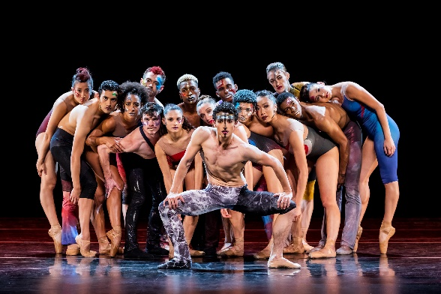
Founders Dwight Rhoden and Desmond Richardson, armed with a rich Alvin Ailey lineage and a cadre of 16 spectacular dancers, have re-envisioned ballet through technical precision, athletic prowess, and sheer passion. Complexions Contemporary Ballet will rock the theater with its blockbuster hit, Stardust featuring a soundtrack celebrating David Bowie classics, including “Young Americans,” “Heroes,” and “Space Oddity.” Tickets start at $30.

PROGRAMMING IN WINTER 2024:

Chicago Sinfonietta presents PULSE
Monday, January 15 at 7:30 PM
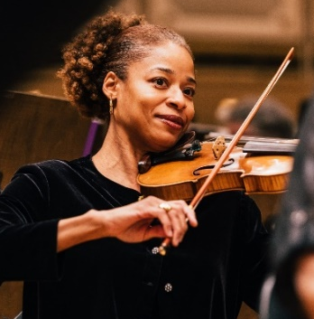
Join the Chicago Sinfonietta in its annual MLK Tribute Concert, PULSE, as the orchestra pays homage to the enduring legacy of Dr. Martin Luther King Jr. with a captivating lineup of works that celebrate the power of perseverance, triumph, and hope. Conducted by Chicago Sinfonietta’s own Mei-Ann Chen, the program includes the dynamic Overture from Treemonisha, Scott Joplin’s classic opera, reimagined for the orchestra by Gunther Schuller; Xavier Dubois Foley’s Victory Concerto, featuring the composer himself on double bass; and Montgomery Variations by Margaret Bonds, a work that showcases the beauty and complexity of Black spirituals and folk songs. Tickets start at $25.

An Evening with John Cusack & Screening of High Fidelity
Thursday, January 18 at 7:30PM
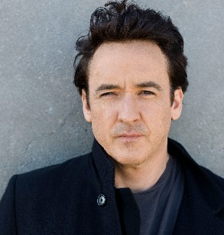
Evanston native, actor John Cusack will host an intimate screening of one of his most popular motion pictures, High Fidelity, followed by a live conversation about the making of the film in Chicago, and an audience Q&A. Tickets start at $39.50.

Compañía Nacional de Danza
Saturday, February 10 at 7:30PM
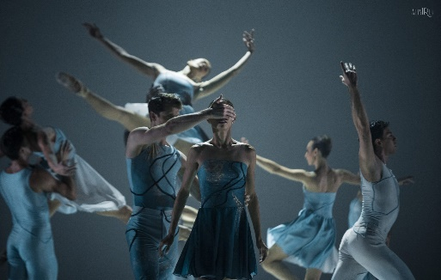
Making its Chicago debut at the Auditorium, the Madrid-based ‘National Dance Company’ performs varied and representative repertoires, recognizable inside and outside Spain, covering classical, neoclassical, and contemporary dance. Compañía Nacional de Danza is led by Artistic Director Joaquín De Luz, a past soloist with American Ballet Theatre and principal dancer with New York City Ballet. The company will perform Passengers Within (2022), a new work by De Luz to music by Philip Glass and inspired by today’s society and our slavery to the system of modern technology. The mixed rep program also includes Sad Case (1998, Sol León and Paul Lightfoot) showcasing the surprising and earthy movements of the mambo; and White Darkness (2001) by acclaimed Spanish modern ballet dancer and choreographer Nacho Duato, current artistic director of the Berlin State Ballet. Tickets start at $40.

North American Premiere of Blade Runner in Concert
Saturday, February 17 at 7:30PM
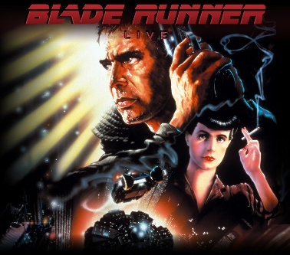
Experience Ridley Scott’s multi-Academy Award®-nominated cult classic, Blade Runner (2007 Final Cut version of the 1982 film), on a vast HD screen while Vangelis’ synthesizer-led score is performed by the Chicago Philharmonic in-sync with the motion picture. In this stylish noir thriller, detective Rick Deckard (Harrison Ford) must continue as Replicant Hunter following the escape of four Replicants from colonies who’ve returned to earth. His mission however is complicated when he falls for Rachel (Sean Young), a Replicant based at the Tyrell Corporation. Tickets start at $59.

Magic of Motown
Saturday, February 24 at 7:30PM
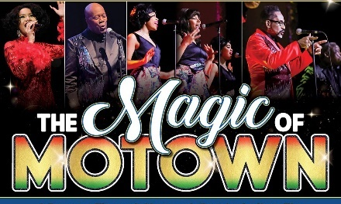
Magic of Motown is a group of 15 power vocalists backed by a six-piece band delivering all the hits from The Temptations, The Jackson Five, Diana Ross & The Supremes, Marvin Gaye, Aretha Franklin and more, with costuming and choreography that transport audiences straight to Motown. Tickets start at $43.

IN THE 30 DAYS FOLLOWING
- Richard Marx with special guest John Waite, March 1
- Trinity Irish Dance, March 3
- MOMIX, March 9
- Chicago Sinfonietta presents ECHO, March 16
- Mitski with Julia Jacklin, March 21-March 24
- Adam Ant- ANTMUSIC 2024 with special guest The English Beat, March 26

ONGOING THEATRE TOURS
The public is invited year-round to take exclusive behind-the-scenes tours to learn about the secrets and stories that make the Auditorium Theatre unique! Explore this national historic landmark designed by famed architects Louis Sullivan and Dankmar Adler like never before. Be awed by taking a closer look at the brilliant 24-karat gold-leafed ceiling arches and the beautifully restored artwork throughout the building. Tours are approximately 80-90 minutes in length and take place Mondays, Wednesdays, and Saturdays at noon. For a reservation, please contact 312.341.2300.
Tickets for all events are now on sale, with more performance dates to be announced! For more information or to purchase tickets, please visit AuditoriumTheatre.org.
###

Media contact:
Alannah Spencer/Beth Silverman
The Silverman Group, Inc.
Alannah@silvermangroupchicago.com
Beth@silvermangroupchicago.com
608-692-4778 (cell)/ 312-560-4783 (cell)

