For Immediate Release
Assets Available HERE

ON STAGE IN MAY AT THE

(February 15, 2024) From Mexican stand-up, to Japanese virtual reality, to everyone’s favorite family of Australian dogs, the not-for-profit Auditorium Theatre (50 E. Ida B. Wells Drive) is dedicated to presenting the finest in international, cultural, community, and educational programming to all of Chicago and beyond as The Theatre for the People. The organization is also committed to the continued restoration and preservation of this National Historic Landmark that originally opened in 1889. Among offerings on the Auditorium Theatre stage in May 2024 (as of mid-February):

MAY SPOTLIGHT:
Auditorium Theatre's 2024 Annual Gala
Thursday, May 9 at 5:30PM

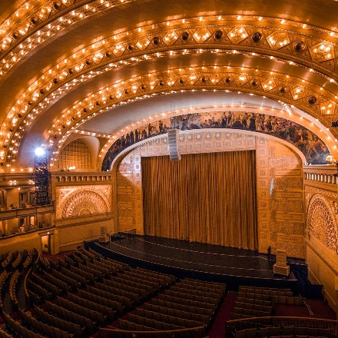
The Auditorium Theatre 2024 Annual Gala takes place at the Palmer House Hilton and includes a cocktail reception, dinner, an awards presentation, and a special musical performance. This year’s honorees are Joyce Chelberg who will receive the Adler & Sullivan Award for her lasting contributions to the arts and her enduring and exceptional dedication to the national Historic Landmark Auditorium Theatre and Michelle T. Boone who will receive the Beatrice Spachner Award for substantially enhancing the cultural fabric of Chicago by demonstrating an exemplary commitment to issues of civic concern, social justice, and community development.

ADDITIONAL PROGRAMMING IN MAY 2024:

Bluey’s Big Play
Friday, May 3 at 6:00PM; Saturday, May 4 at 11:00AM, 2:00PM, & 5:00PM; Sunday, May 5 at 2:00PM
Bluey’s Big Play is a brand-new theatrical adaptation of the Emmy® award-winning children’s television series, with an original story by Bluey creator Joe Brumm, and new music by Bluey composer, Joff Bush. Join the Heelers in their first live theatre show made just for you, featuring brilliantly created puppets, brought to real life. When Dad feels like a little bit of Sunday afternoon time out, Bluey and Bingo have other plans! Join them as they pull out all of the games and cleverness at their disposal to get Dad off that bean bag. Tickets start at $33.00.

Chicago Sinfonietta presents REVERB
Saturday, May 11 at 7:30PM
Join the Chicago Sinfonietta for an unforgettable season finale, REVERB, featuring a lineup of works that showcase the power and energy of classical music. First is Chin’s Subito con Forza, a dynamic work that sets the tone for an evening, followed by Symphony No. 3 by Louise Farrenc, whose brilliance as a composer is finally receiving the recognition it deserves. Up next, experience the Chicago premiere of Carlos Simon’s Profiles, a work that explores the complexities of identity and the diversity of the human experience. Rachmaninoff’s Rhapsody on a Theme of Paganini, featuring the world-renowned pianist George Li closes the program. Tickets start at $25.00.

Hatsune Miku – Miku Expo 2024
Tuesday, May 14 at 8:00PM
Hatsune Miku is a Japanese music sensation, a 16 year-old blue-haired girl with a unique voice and prodigious energy. What makes her special is that she is not a human singer, but a virtual persona who uses a computer-generated voice and 3D graphics to perform on stage. With a repertoire entirely provided by individual creators, she is the first truly crowd-created virtual talent. But being virtual doesn’t stop her from filling up concert halls or teaming up with major artists like Lady Gaga and Pharrell Williams. Tickets are currently sold out.

Sofia Niño de Rivera – Gira 2024
Friday, May 24 at 8:00PM
Niño de Rivera is a Mexican stand-up comedienne and actress. She was named Mexico City’s woman of the year in 2016 by the Mexican entertainment magazine Chilango. She started to appear in the Spanish comedy-drama “Club de Cuervos” as the character Emilia in 2015. In 2016, she became the first Spanish-speaking woman to receive her own comedy special from Netflix. It was successful enough that another comedy special was released in 2018 with “Sofia Niño de Rivera: Selecion Natural.” She also appeared in the comedy “Recuperando a mi ex.” She has a series on YouTube Originals called “Sobrevivi.” Tickets start at $59.00.

An Evening with John Cusack & Screening of High Fidelity
Friday, May 31 at 7:30PM
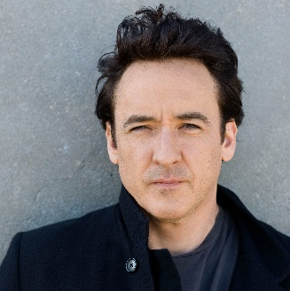
Actor John Cusack will host an intimate screening of one of his most popular motion pictures, High Fidelity, followed by a live conversation about his career and the making of the film, followed by a Q&A. John Cusack’s show at Auditorium Theatre was scheduled for January 18, and has been postponed to Friday, May 31 at 7:30PM. All previously purchased tickets will be honored for the new date. Tickets start at $39.50.

THIS SUMMER AT THE AUDITORIUM THEATRE
- Good Mythical Tour with Rhett & Link, June 1
- Marvel Studios’ Black Panther in Concert: part of the Auditorium Philms Series, June 22-23
- Future Islands, June 28
- Heroes: A Video Game Symphony, July 13
ONGOING THEATRE TOURS
The public is invited year-round to take exclusive behind-the-scenes tours to learn about the secrets and stories that make the Auditorium Theatre unique! Explore this national historic landmark designed by famed architects Louis Sullivan and Dankmar Adler like never before. Be awed by taking a closer look at the brilliant 24-karat gold-leafed ceiling arches and the beautifully restored artwork throughout the building. Tours are approximately 80-90 minutes in length and take place Mondays, Wednesdays, and Saturdays at noon. For a reservation, please contact 312.341.2300.
Tickets for all events are now on sale, with more performance dates to be announced! For more information or to purchase tickets, please visit AuditoriumTheatre.org.
###

Media contact:
Alannah Spencer/Beth Silverman
The Silverman Group, Inc.
Alannah@silvermangroupchicago.com
Beth@silvermangroupchicago.com
608-692-4778 (cell)/ 312-560-4783 (cell)

