Alvin Ailey, South Chicago Dance Theatre, Auditorium Philms and more!
For Immediate Release
Assets Available HERE

ON STAGE IN APRIL AT THE

(January 18, 2024) From Gospel to Gotham, the not-for-profit Auditorium Theatre (50 E. Ida B. Wells Drive) is dedicated to presenting the finest in international, cultural, community, and educational programming to all of Chicago and beyond as The Theatre for the People. The organization is also committed to the continued restoration and preservation of this National Historic Landmark that originally opened in 1889. Among offerings on the Auditorium Theatre stage in April 2024 (as of mid-January):

APRIL SPOTLIGHT:
Alvin Ailey American Dance Theater
Wednesday, April 17 – Sunday, April 21

Celebrating over 55 years of partnership with the Auditorium Theatre, the illustrious Alvin Ailey returns to its Chicago home for a must-see six-performance program with both new works and beloved classics including Ailey’s masterpiece Revelations. Now in its 65th Anniversary season, the company will perform three distinct programs certain to appeal to both longtime Ailey fans and new ones discovering this joyous company for the first time: AUDIENCE FAVORITES, ALL NEW, and AILEY CLASSICS. Steeped in cultural history and expanding with new boundary-breaking choreographers, this is truly a must-see event! Tickets start at $40.00.

ADDITIONAL PROGRAMMING IN APRIL 2024:

One Hallelujah
Thursday, April 4 at 6:30PM
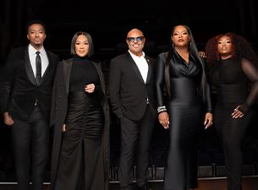
Five of the biggest names in American Gospel music today --Tasha Cobbs Leonard, Jonathan McReynolds, Erica Campbell, Israel Houghton, and Jekalyn Carr -- join forces for their 2024 tour ‘One Hallelujah.’ The 25-city tour kicks off on March 6 at MGM Music Hall at Fenway in Boston making stops across the U.S. in New York, Atlanta, Nashville, New Orleans, Houston, and more, The super-group spends one night only in Chicago at the Auditorium Theatre on April 4. Tickets start at $39.95.

Croce Plays Croce 50th Anniversary Tour
Saturday, April 6 at 8:00PM
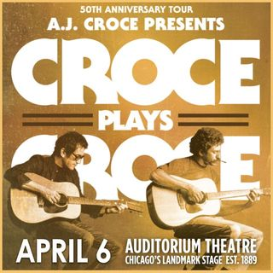
Multi-faceted singer/songwriter A.J. Croce is hitting the road again in celebration of two more of his father Jim Croce’s legendary albums, 1973’s Life and Times and his final release, I Got A Name, in addition to songs from You Don’t Mess Around With Jim. Croce Plays Croce 50th Anniversary features a legendary band (including drummer Gary Mallaber, bassist David Barard, guitar/violin James Pennebaker) and a moving multi-media presentation accompanying Jim’s songs (which on the previous tour included memorable hits, “Operator (That’s Not the Way It Feels)”, “Time in a Bottle,” and others). Tickets start at $41.50.

Batman 1989 – 35th Anniversary Concert
Saturday, April 13 at 7:30PM
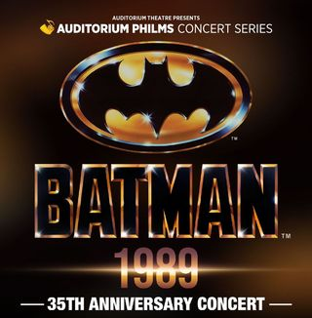
Celebrate the 35th Anniversary of Warner Bros. Pictures’ iconic 1989 DC Superhero film, Batman, live in concert! The Dark Knight, defender of law and order in Gotham City, treads the shadow zone between right and wrong, always keeping his true identity as millionaire philanthropist Bruce Wayne a closely guarded secret. The film will be accompanied live by the Chicago Philharmonic Orchestra, conducted by James Olmstead, providing the perfect opportunity to revisit a classic fan-favorite film. Guests are encouraged to dress up as their favorite DC Superhero. Batman 1989 is part of the newly launched Auditorium Philms series. Tickets start at $69.00.

South Chicago Dance Theatre
Saturday, April 27 at 7:30PM
In its 7th season, South Chicago Dance Theatre is a flourishing local company that presents a seamless fusion of classical and contemporary dance. The evening will feature six world premieres and new collaborations with esteemed and fresh choreographers Donald Byrd, Joshua Blake Carter, Monique Haley, Tsai Hsi Hung, Terence Marling, and founding Executive Artistic Director Kia S. Smith. Tickets start at $25.00.

IN THE 30 DAYS FOLLOWING
- An Evening with Alan Ruck and Screening of Ferris Bueller’s Day Off, May 2
- Bluey’s Big Play, May 5
- Chicago Sinfonietta presents REVERB, May 11
- Hatsune Miku – Miku Expo, May 14
- Sofia Niño de Rivera – Gira 2024, May 24
ONGOING THEATRE TOURS
The public is invited year-round to take exclusive behind-the-scenes tours to learn about the secrets and stories that make the Auditorium Theatre unique! Explore this national historic landmark designed by famed architects Louis Sullivan and Dankmar Adler like never before. Be awed by taking a closer look at the brilliant 24-karat gold-leafed ceiling arches and the beautifully restored artwork throughout the building. Tours are approximately 80-90 minutes in length and take place Mondays, Wednesdays, and Saturdays at noon. For a reservation, please contact 312.341.2300.
Tickets for all events are now on sale, with more performance dates to be announced! For more information or to purchase tickets, please visit AuditoriumTheatre.org.
###

Media contact:
Alannah Spencer/Beth Silverman
The Silverman Group, Inc.
Alannah@silvermangroupchicago.com
Beth@silvermangroupchicago.com
608-692-4778 (cell)/ 312-560-4783 (cell)

