‘Alice in Wonderland’ inspired production invites the whole family down the rabbit hole
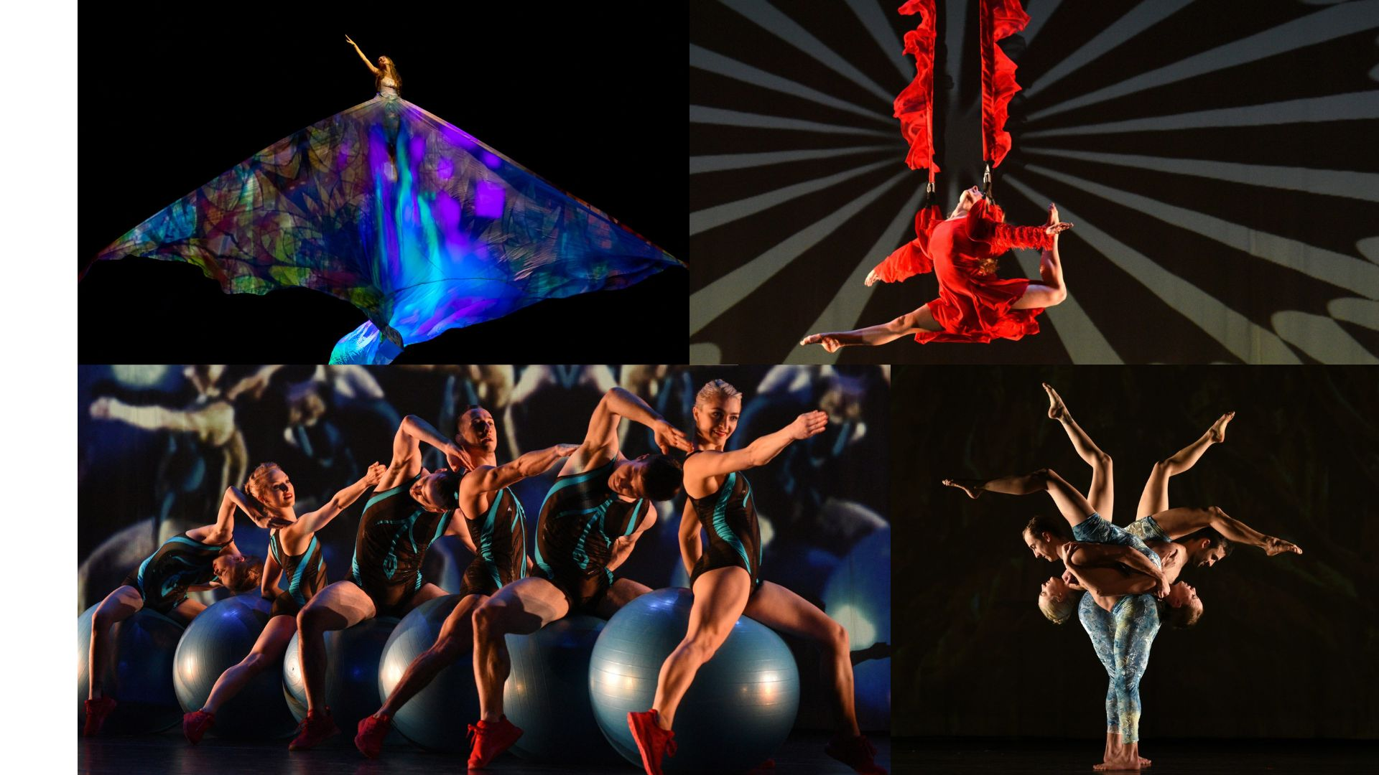

For Immediate Release
PHOTOS AVAILABLE HERE

The Auditorium Theatre Proudly Presents
MOMIX in ALICE
One night only, Saturday, March 9 at 7:30 PM

Dance, acrobatics, and illusion combine in a mind-bending and visually arresting take on the classic tale Alice in Wonderland

January 29, 2024 (CHICAGO) – The Auditorium Theatre (Chicago’s landmark stage at 50 E. Ida B. Wells Drive) proudly presents MOMIX, the internationally renowned company of dancer-illusionists founded by Moses Pendleton. Known for presenting works of astounding inventiveness and physical beauty, MOMIX makes its long-awaited return to the Auditorium Theatre for the first time since 1997. MOMIX will dazzle Chicago audiences once again, this time with a trip down the rabbit hole for ALICE, inspired by Alice in Wonderland with a signature MOMIX twist. As Alice’s body grows and shrinks and grows again, Pendleton’s dancers extend themselves by means of props, ropes and other dancers creating a family-friendly journey that is as magical and fun as it is beautiful and mysterious. The MOMIX production of ALICE takes place Saturday, March 9 at 7:30 PM at the Auditorium Theatre. Tickets start at $30.00 and can be purchased at auditoriumtheatre.org. This production is recommended for audiences age 6 and up.

Using the story of Alice in Wonderland as a point of inspiration, ALICE reintroduces classic characters including the white rabbit, the Cheshire Cat, and the Queen of Hearts in imaginative and surprising ways. ALICE pushes the boundaries of what a MOMIX production can be by fusing the signature MOMIX movement style and theatricality with cutting edge technical elements in lighting, music, costumes, and projected imagery.

“We are thrilled to bring MOMIX back to the Auditorium Theatre,” said Auditorium Theatre CEO Rich Regan. “The MOMIX blend of contemporary dance and brilliantly crafted visual illusions must be seen to be believed. Beloved by fans of dance, theater, circus, and visual art, there is something in a MOMIX performance for everyone.”

About MOMIX
MOMIX, a company of dancer-illusionists founded and directed by Moses Pendleton, has been presenting work of exceptional inventiveness and physical beauty for more than 40 years. From its base in Washington, Connecticut, the company has developed a devoted worldwide following. In addition to stage performances, MOMIX has also worked in film and television, as well as corporate advertising, with national commercials for Hanes and Target, and presentations for Mercedes-Benz, Fiat, and Pirelli. With performances on PBS’s “Dance in America” series, France’s Antenne II, and Italian RAI television, the company’s repertory has been beamed to 55 countries. The Rhombus Media film of Mussorgsky’s Pictures at an Exhibition with MOMIX and the Montreal Symphony was the winner of an International Emmy for Best Performing Arts Special. MOMIX was also featured in IMAGINE, one of the first 3-D IMAX films released in IMAX theaters worldwide. MOMIX dancers Cynthia Quinn and Karl Baumann, under Pendleton’s direction, played the role of “Bluey” in the feature film F/X2, and White Widow, co-choreographed by Pendleton and Quinn, was featured in the Robert Altman film The Company, starring Chicago’s own Joffrey Ballet. With nothing more than light, shadow, fabric, props, and the human body, MOMIX continues to astonish and delight audiences on five continents.

About The Auditorium Theatre
The Auditorium Theatre, located at 50 E. Ida B. Wells Drive at Roosevelt University in Chicago, is an Illinois not-for-profit organization committed to presenting the finest in international, cultural, community, and educational programming to all of Chicago and beyond as The Theatre for the People. The organization also is committed to the continued restoration and preservation of this National Historic Landmark that originally opened in 1889.

This Auditorium Theatre’s 2023-24 performance season features a dynamic mix of cultural events from ballet to rock and roll and everything in between. For more information on the Auditorium Theatre and a complete listing of events at the Auditorium Theatre, please visit AuditoriumTheatre.org.

###
Photo Credits: (Clockwise from top left) Alice-photo by Sharen Bradford; Queen of Diamonds-Photo by Equilibre Monaco; Caterpillar-Photo by Equilibre Monaco; Garden of Live Creatures-Photo by Equilibre Monaco

MEDIA CONTACT FOR AUDITORIUM THEATRE
Alannah Spencer/ Beth Silverman
The Silverman Group, Inc.
Alannah@silvermangroupchicago.com
Beth@silvermangroupchicago.com
608-692-4778 (m)

