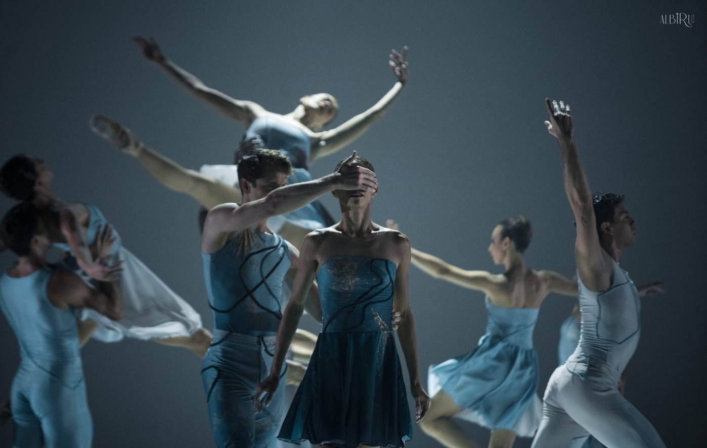

For Immediate Release
PHOTOS AVAILABLE HERE

The Auditorium Theatre Proudly Presents
Compañía Nacional de Danza
One night only, Saturday, February 10 at 7:30 PM

Madrid-Based ‘National Dance Company’ makes Chicago Debut at Auditorium Theatre

January 8 (CHICAGO) – The Auditorium Theatre (Chicago’s landmark stage at 50 E. Ida B. Wells Drive) proudly presents Compañía Nacional de Danza (CND) in their Chicago debut. The Madrid-based ‘National Dance Company’ will perform a mixed repertory program featuring varied and representative styles, recognizable inside and outside Spain, including classical, neoclassical, and contemporary dance. The one night only performance is Saturday, February 10 at 7:30 PM at the Auditorium Theatre. Tickets start at $40 and are available at auditoriumtheatre.org.

Compañía Nacional de Danza is led by Artistic Director Joaquín De Luz, a past soloist with American Ballet Theatre and principal dancer with New York City Ballet. CND will perform a varied mixed repertory program including; Passengers Within (2022), a new work by De Luz to music by Philip Glass and inspired by today’s society and our slavery to the system of modern technology. The program also includes Sad Case (1998) choreographed by former Nederlands Dans Theater dancers Sol León and Paul Lightfoot showcasing the surprising and earthy movements of the mambo; and White Darkness (2001) by acclaimed Spanish modern ballet dancer and choreographer Nacho Duato, former CND director and current artistic director of the Berlin State Ballet.

“The Auditorium Theatre is especially proud to host Compañía Nacional de Danza for their Chicago debut performance.” Said Auditorium Theatre CEO Rich Regan “A group of Auditorium Theatre donors and myself traveled to Spain last year. During this trip, we saw CND perform, and were all so blown away by the artistry and technical precision of the company that we immediately began planning how to bring them to the Auditorium. We are excited to be able to share this excellent company with Chicago audiences for the first time.”

Compañía Nacional de Danza Master Class
On Saturday, February 10 from 10:30 a.m. – 12:00 noon, Pino Alosa, the Assistant Artistic Director of Compañía Nacional de Danza, will lead a free 90-minute master class, giving local dancers at the advanced level the opportunity to learn from illustrious members of one of the great international dance companies. The class is limited to 25 dancers, filled on a first registered, first served basis, and are for dancers who have 4-5 years of training. Class will be held in the Auditorium Theatre’s Katten-Landau Studio and is free with advanced registration. Registration is available at auditoriumtheatre.org

About Compañía Nacional de Danza
Celebrating its 45th Anniversary in 2024, the mission of Compañía Nacional de Danza is to promote and disseminate the art of dance and its repertoire, open to all styles, choreographic languages ​​and movement arts in general, both Spanish and international creation. The company was founded in 1979 with the name of Ballet Clásico Nacional under director Víctor Ullate. In June 1990, Nacho Duato was appointed artistic director of the National Dance Company, a position he held for twenty years, until July 2010. His incorporation represented an innovative change in the history of the training, including it in the company's repertoire. new original choreographies, along with others of proven quality. Joaquín De Luz has served as the company’s director since 2019. For more information visit cndanza.mcu.es.

About The Auditorium Theatre
The Auditorium Theatre, located at 50 E. Ida B. Wells Drive at Roosevelt University in Chicago, is an Illinois not-for-profit organization committed to presenting the finest in international, cultural, community, and educational programming to all of Chicago and beyond as The Theatre for the People. The organization also is committed to the continued restoration and preservation of this National Historic Landmark that originally opened in 1889.

This Auditorium Theatre’s 2023-24 performance season features a dynamic mix of cultural events from ballet to rock and roll and everything in between. For more information on the Auditorium Theatre and a complete listing of events at the Auditorium Theatre, please visit AuditoriumTheatre.org.

###

MEDIA CONTACT FOR AUDITORIUM THEATRE
Alannah Spencer/ Beth Silverman
The Silverman Group, Inc.
Alannah@silvermangroupchicago.com
Beth@silvermangroupchicago.com
608-692-4778 (m)

