Chicago Philharmonic performs all-electric futuristic score to the cult-classic film
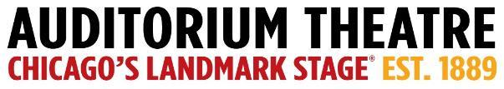
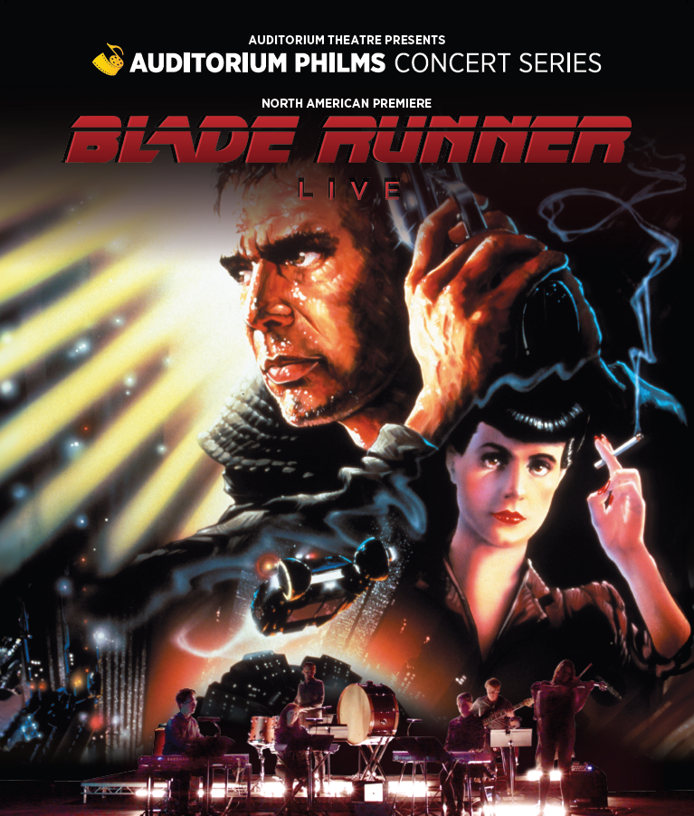
For Immediate Release
PHOTOS AVAILABLE HERE

AUDITORIUM PHILMS CONCERT SERIES debuts with North American premiere of Blade Runner in concert

One night only Saturday, February 17 at 7:30 PM
At the Auditorium Theatre

See the classic sci-fi action film on the big screen while the Chicago Philharmonic performs the iconic score live on stage

January 11, 2024 (CHICAGO) – The Auditorium Theatre (Chicago’s landmark stage at 50 E. Ida B. Wells Drive) proudly kicks-off the new Auditorium Philms Concert Series, a new multi-media experience presenting iconic films brought to life with scores performed in concert by the Chicago Philharmonic, with the North American premiere of one of the all-time sci-fi classics Blade Runner. The original 1982 film (2007 final cut) will play in its entirety on the big screen of the iconic Auditorium Theatre stage while an all-electric 11-piece chamber orchestra made up of members of the Chicago Philharmonic perform the thrilling futuristic score by Vangelis mixed in-sync with dialogue and sound effects from the original film. The one night only performance is Saturday, February 17 at 7:30 PM at the Auditorium Theatre, 50 E Ida B Wells Dr. Tickets start at $59.00 and are available at auditoriumtheatre.org.

Ridley Scott’s multi-Academy Award®-nominated Blade Runner follows detective Rick Deckard (Harrison Ford) as he hunts down four bio-engineered synthetic humans, or Replicants, from space colonies who’ve returned to earth. His mission however is complicated when he falls for Rachel (Sean Young); a Replicant based at the Tyrell Corporation. Hailed as one of the greatest sci-fi movies of all time, Blade Runner has become a beloved cult-classic spawning numerous sequels and spin-offs. Composed by the forward-thinking Greek orchestral and electronic music composer Vangelis, the soundtrack was nominated for both a BAFTA and a Golden Globe. The film’s score was revolutionary for electronic music, with Vangelis' mastery of the Yamaha CS80, a powerful and complex synthesizer that permeated the sonic soundscape of the 1980s and beyond.

“The Auditorium Philm series continues our partnership with the Chicago Philharmonic,” said Auditorium Theatre CEO Rich Regan. “We are looking forward to kicking off this thrilling new series with a film as beloved as Blade Runner.”

Added Chicago Philharmonic Executive Director Terell Johnson, “At Chicago Philharmonic, we are committed to bringing cutting-edge, innovative programs to life. It's fitting that we're kicking off this major concert series with a film and music score that show the brilliant possibilities at the intersection of music and technology. We believe that the future of the performing arts lies in innovation and collaboration. It's an honor to expand our long-time partnership with the Auditorium Theatre for this thrilling concert and year-long series."

The inaugural 2024 Auditorium Philms Concert Series continues with Batman 1989 in its 35th Anniversary year, April 13; the return of Marvel Studios’ Black Panther after Chicago Philharmonic’s triumphant 2022 Chicago Premiere of the film concert, June 22 & 23; the North American debut of Bram Stoker’s Dracula just in time for Halloween, October 26; and the pop holiday fan favorite, Love Actually, December 7. Subscription packages with discounted tickets are available for as few as two or up to six films. Find out more information about the series at auditoriumtheatre.org/.

About The Chicago Philharmonic Society
Founded by musicians of the Lyric Opera Orchestra in 1979, The Chicago Philharmonic Society is a collaboration of nearly 200 of the highest-level classical musicians in the Midwest. The orchestra, known as the Chicago Philharmonic, has been called one of the country’s finest symphonic orchestras. The brilliance of Chicago Philharmonic’s structure is in its versatility - the organization curates the best ensemble for each concert from an exceptional pool of musicians, be it classical, jazz, pops, movie concerts, outreach programming, and everything else. Find out more about Chicago Philharmonic at chicagophilharmonic.org.

About The Auditorium Theatre
The Auditorium Theatre, located at 50 E. Ida B. Wells Drive at Roosevelt University in Chicago, is an Illinois not-for-profit organization committed to presenting the finest in international, cultural, community, and educational programming to all of Chicago and beyond as The Theatre for the People. The organization also is committed to the continued restoration and preservation of this National Historic Landmark that originally opened in 1889.

The Auditorium Theatre’s 2023-24 performance season features a dynamic mix of cultural events from ballet to rock and roll and everything in between. For more information on the Auditorium Theatre and a complete listing of events at the Auditorium Theatre, please visit AuditoriumTheatre.org.

###

MEDIA CONTACT
Alannah Spencer/ Beth Silverman
The Silverman Group, Inc.
Alannah@silvermangroupchicago.com
Beth@silvermangroupchicago.com
608-692-4778 (m)

