For Immediate Release
Assets including release PDF HERE

ON STAGE IN DECEMBER AT THE

(November 16, 2023) From holiday cheer to thoughtful conversations, the not-for-profit Auditorium Theatre (50 E. Ida B. Wells Drive) is dedicated to presenting the finest in international, cultural, community, and educational programming to all of Chicago and beyond as The Theatre for the People. The organization is also committed to the continued restoration and preservation of this National Historic Landmark that originally opened in 1889. Among offerings on the Auditorium Theatre stage in December 2023 (as of mid- November):

DECEMBER SPOTLIGHT:
Celebrate the Holidays at the Auditorium
November 25- January 13

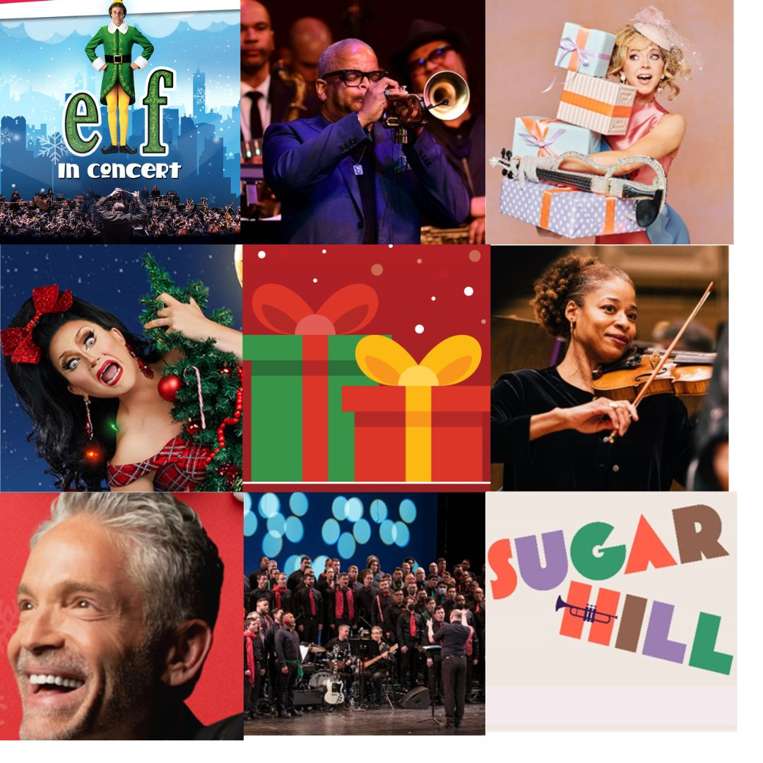
There is something for everyone during the holidays at the Auditorium Theatre. For music lovers, kicking off the Auditorium’s holiday programming in late November is a screening of family-favorite Christmas movie Elf In Concert with a live orchestra playing the film score. Then, in December, Chicago Gay Men’s Chorus celebrates both the holidays and its 40th Anniversary with The Big 4-0, ho ho!, acclaimed saxophonist Dave Koz and Friends present the 26th rendition of the longest running Christmas tour in jazz history, and Chicago Sinfonietta performs an orchestral extravaganza of holiday music from across the globe in HOLIDAY OF LIGHTS. For fans of drag, the Queens of Christmas Jinkx Monsoon and BenDeLaCreme return to the Auditorium for the Jinkx and DeLa Holiday Show. And for the dance connoisseurs, Sugar Hill: The Ellington/Strayhorn Nutcracker will spend two weeks at the Auditorium bringing a unique reimagined jazz Nutcracker to Chicago for the first time. The Auditorium celebrates New Years Eve with pop violinist Lindsey Stirling’s Snow Waltz Tour and keeps the holiday magic going into January with seven-time Grammy award winning trumpeter and composer Terence Blanchard performing music from his film scores.

PROGRAMMING IN DECEMBER:

Damien Rice
Friday, December 1, at 7:30PM
Damien Rice was born in Ireland, and his first album ‘o’ was recorded at home and self-released in Ireland. Numerous tours followed, along with two more albums ‘9’ and ‘My Favourite Faded Fantasy.’ Having the unconventional tendency to prefer walking on stage with no setlist, Rice also prefers to travel by sailboat rather than by tour bus and is planning a sailboat-tour in the Mediterranean in the summer of 2023. This will be Damien’s first performance in Chicago since 2008, and his only Midwest performance in 2023. Tickets start at $39.50.

Geddy Lee – My Effin’ Life In Conversation
Sunday, December 3, at 8PM
Geddy Lee will give his fans a peek into the very fabric of his life: from a deep reflection of his family and childhood, to a dive into the history of Rush and personal memories with his life-long friends and band-mates, Alex Lifeson and Neil Peart. Joined on stage by a special guest interviewer, Geddy Lee will read key passages from his forthcoming book My Effin’ Life and share thoughts and stories taken from his experience. Fans will then have the chance to participate in a special Q&A. Every ticket sold will include a copy of Geddy Lee’s forthcoming book. Tickets start at $85.

WBEZ and The University Club of Chicago Present: Michael Lewis in Conversation with Andrew Ross Sorkin
Thursday, December 7 at 7:30PM
Best-selling author Michael Lewis had a front row seat for the collapse of crypto currency exchange FTX and the illicit practices that now have its founder, Sam Bankman-Fried, looking at life in prison. Michael will discuss his new book on SBF, Going Infinite: The Rise and Fall of a New Tycoon, with Andrew Ross Sorkin, New York Times journalist and co-anchor of CNBC’s Squawk Box. A signed copy of the book is included with each ticket. Tickets tart at $57.

Chicago Gay Men’s Chorus: The Big 4-0, ho, ho!
Friday, December 8, at 8PM
Chicago Gay Men’s Chorus celebrates its 40th Anniversary with The Big 4-0, ho, ho! a celebration of CGMC’s holiday favorites over the last 40 years. Featuring festive arrangements from current Artistic Director Jimmy Morehead and a plethora of music from Chorus Alumni. This choral show honors how far the chorus has come as an LGBTQIA+ organization and proves that we are still here. Join in on the fun and ring in the holidays as we prepare to raise our voices for another 40 years! Tickets start at $29.

Dave Koz and Friends Christmas Tour 2023
Saturday, December 9, at 8PM
Jazz saxaphonist Dave Koz and Friends perform the 26th anniversary edition of the longest-running jazz-based Christmas tour featuring fresh renditions of timeless classics alongside hits from their respective catalogues. The tour reunites Koz with long-time musical partner, guitarist/singerJonathan Butler and will feature special guests, saxophonist/flutist Marcus Anderson, vocalist Rebecca Jade, and 16-year old musical prodigy, pianist/guitarist/vocalist Justin-Lee Schultz. Tickets start at $39.50.

The Jinkx & DeLa Holiday Show
Sunday, December 10, at 8PM
The (drag) Queens of Christmas are coming back to the Auditorium Theatre with a brand new edition of the internationally acclaimed The Jinkx & DeLa Holiday Show. Another holiday season brings another year of fabulous spectacle, whip – smart comedy, brand new songs, and annual favorites. Join the sugary DeLa and spicy Jinkx for an evening the New York Times says is “sure to lift your spirits and make you howl with laughter.” This show may contain adult themes and language. Tickets start at $49.50.

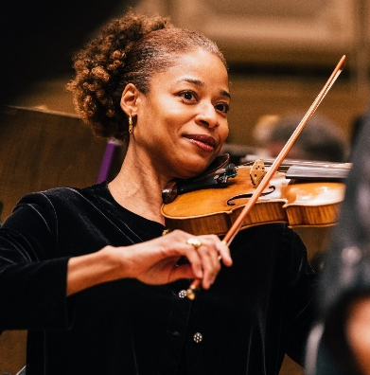
Chicago Sinfonietta presents HOLIDAYS OF LIGHT
Friday, December 15, at 7:30PM
Chicago Sinfonietta’s annual holiday concert, with guest conductor Chelsea Tipton, features an exciting array of holiday music, ranging from classic Christmas favorites to traditional Jewish and Latin American tunes. With tunes like “White Christmas,” Lukas Richman’s “Hanukkah Festival Overture,” Duke Ellington’s jazzy and playful “Nutcracker Suite, Johann Strauss’s “Champagne Polka,” and Leroy Anderson’s perennial favorite “Sleigh Ride.” The audience will then join in for a heartwarming rendition of “Silent Night,” while luminarias light up the hall. Tickets start at $25.00.

Sugar Hill: The Ellington/Strayhorn Nutcracker
Tuesday, December 19 – Saturday, December 30
An exhilarating story told in dance, Sugar Hill is set to the music of the genre-defying collaboration between jazz icons Duke Ellington and Billy Strayhorn in a captivating way that has never been done before. Sugar Hill reveals the glamour of the 1930s as seen through the lens of the nonconformist daughter of a high-society Black family in Manhattan and her fantastic dreamworld in the Sugar Hill neighborhood of Harlem. A jazz-steeped reimagining of the classic tale, this Nutcracker sends a stirring message that champions individuality and the journey to find the power of your unique self. Tickets start at $44.

Lindsey Stirling – Snow Waltz Tour
Sunday, December 31 at 8:30PM
The Auditorium Theatre rings in the new year with Lindsey Stirling. For over a decade, Stirling has enchanted audiences across the globe by performing a certain spellbinding magic with her electronic violin, dreaming up an exquisitely composed yet boldly inventive sound entirely her own. On her new album Snow Waltz, the classically trained musician/songwriter/dancer/author finds herself fully in her element, sharing a selection of holiday classics and original songs that evoke intense emotion through her immersive arrangements and mesmerizing melodies. Tickets start at $49.

IN THE NEXT 60 DAYS
- Terence Blanchard: Film Scores LIVE!, January 13, 2024
- Chicago Sinfonietta Presents PULSE, January 15
- An Evening with John Cusack & Screening of High Fidelity, January 18
- Complexions Contemporary Ballet, February 3
- Compañía Nacional de Danza, February 10
- North American Premiere of Blade Runner In Concert, February 17

AND ON SALE SOON:
Film lovers rejoice as the Auditorium Theatre proudly announces the debut of the Auditorium Philms Concert Series, a major new multi-media experience presenting five iconic films brought to life with scores performed in concert by the Chicago Philharmonic, the city’s go-to orchestra for film score collaborations. Launching February 17, 2024, with the futuristic classic Blade Runner making its North American premiere In Concert, the inaugural 2024 Auditorium Philms Concert Series continues with Batman 1989, Marvel Studios’ Black Panther, the North American premiere of Bram Stoker’s Dracula and Love Actually. Individual tickets, starting at $59.00, along with Philms series packages for as few as 2 concerts and as low as $106.00, go on sale at noon, Friday, Nov. 17, by visiting auditoriumtheatre.org/.
ONGOING THEATRE TOURS
The public is invited year-round to take exclusive behind-the-scenes tours to learn about the secrets and stories that make the Auditorium Theatre unique! Explore this national historic landmark designed by famed architects Louis Sullivan and Dankmar Adler like never before. Be awed by taking a closer look at the brilliant 24-karat gold-leafed ceiling arches and the beautifully restored artwork throughout the building. Tours are approximately 80-90 minutes in length and take place Mondays, Wednesdays, and Saturdays at noon. For a reservation, please contact 312.341.2300.
Tickets for all events are now on sale, with more performance dates to be announced! For more information or to purchase tickets, please visit AuditoriumTheatre.org.
###

Media contact:
Beth Silverman/Alannah Spencer
The Silverman Group, Inc.
Beth@silvermangroupchicago.com
Alannah@silvermangroupchicago.com
312-560-4783 (cell) / 608-692-4778 (cell)

