Length World Premiere of “Madonna Anno Domini” choreographed by Nicole Clarke-Springer
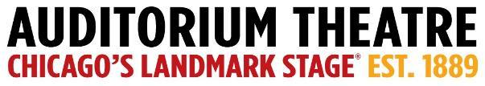

For Immediate Release
PHOTOS AVAILABLE HERE

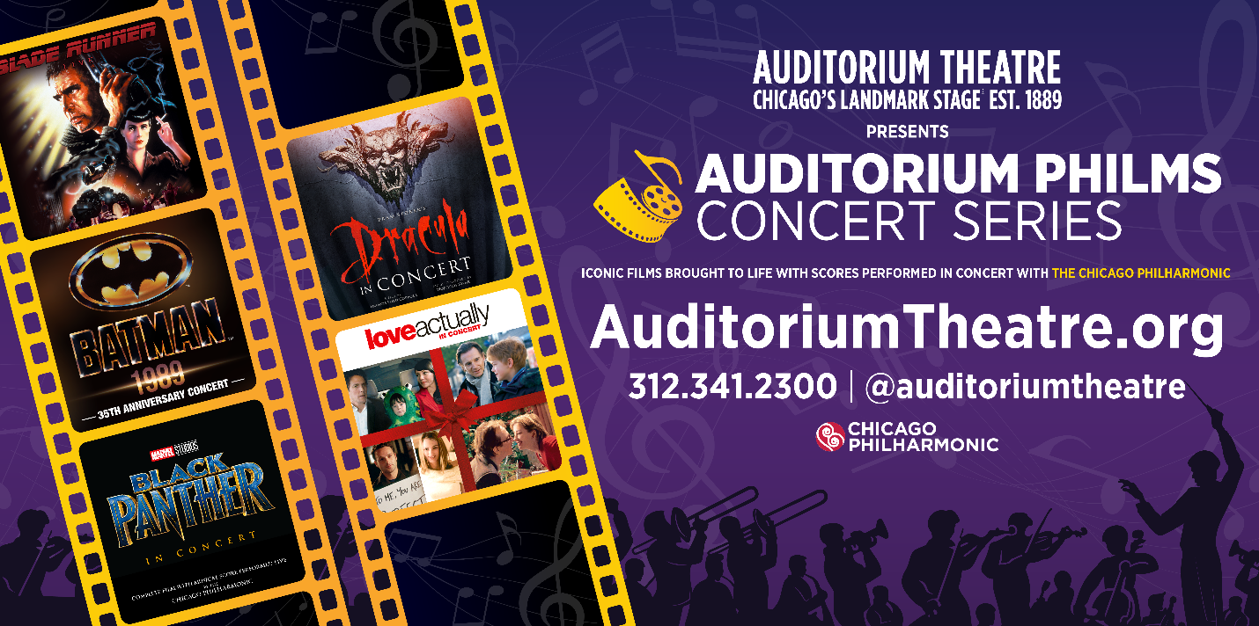
Major new AUDITORIUM PHILMS CONCERT SERIES
debuts in 2024!

The AUDITORIUM THEATRE proudly presents five iconic films brought to life with
scores performed in concert by the critically acclaimed CHICAGO PHILHARMONIC.

Inaugural 2024 Philms roster includes Blade Runner, Batman 1989, Black Panther,
Bram Stoker’s Dracula, and Love Actually

November 13, 2023 (CHICAGO) – Film lovers rejoice as the Auditorium Theatre (Chicago’s landmark stage at 50 E. Ida B. Wells Drive) proudly announces the debut of the Auditorium Philms Concert Series, a major new multi-media experience presenting five iconic films brought to life with scores performed in concert by the Chicago Philharmonic, the city’s go-to orchestra for film score collaborations. Launching February 17, 2024, with the futuristic classic Blade Runner, the inaugural 2024 Auditorium Philms Concert Series continues with Batman 1989 in its 35th Anniversary year, April 13; the return of Marvel Studios’ Black Panther after Chicago Philharmonic’s triumphant 2022 Chicago Premiere of the film concert, June 22 & 23; the North American debut of Bram Stoker’s Dracula just in time for Halloween, October 26; and the pop holiday fan favorite, Love Actually, December 7. Individual tickets, starting at $59.00, along with Philms series packages for as few as 2 concerts and as low as $106.00, go on sale at noon, Friday, Nov. 17, by visiting auditoriumtheatre.org/.

“The great popularity of the Auditorium’s one-off film concert programs with Chicago Philharmonic, including rousing presentations of Ghostbusters and The Godfather, led us to collaborate on what we expect to become an annual series,” said Auditorium Theatre CEO Rich Regan. “From vampires to replicants, from a bumbling British Prime Minister to iconic superheroes, there truly is something for everyone in 2024, and we hope both film lovers and those who enjoy lush orchestral arrangements will give this series two thumbs up!”

Added Chicago Philharmonic Executive Director Terell Johnson, “This is a natural extension of our strong partnership with the historic Auditorium Theatre. We believe partnerships like this are the future of our industry. Together, we can create truly magical experiences for thousands of audience members, many of whom will be completely new to live symphonic music.”

The 2024 Auditorium Philms Concert Series titles:

Blade Runner - Saturday, February 17, 2024, at 7:30 PM
Experience Ridley Scott’s multi-Academy Award®-nominated cult classic, Blade Runner (2007 Final Cut), on a vast HD screen while Vangelis' revolutionary synthesizer-led score (featuring the innovative Yamaha CS-80 that defined the sound of the 1980s) is performed by the Chicago Philharmonic Chamber Orchestra in-sync with the original 1982 motion picture. In this stylish noir thriller, detective Rick Deckard (Harrison Ford) must continue as Replicant Hunter following the escape of four Replicants from colonies who’ve returned to earth. His mission however is complicated when he falls for Rachel (Sean Young); a Replicant based at the Tyrell Corporation.

Batman ‘89 – Saturday, April 13, 2024, at 7:30 PM
This one-night-only event celebrates the 35th Anniversary of Warner Bros. Pictures’ iconic 1989 DC Superhero film, Tim Burton’s Batman, and its dynamic score by Danny Elfman (with additional tracks by Prince). As portrayed by Michael Keaton, the Dark Knight, defender of law and order in Gotham City, treads the shadow zone between right and wrong, fighting with only his skill in martial arts and his keenly honed mind to defend the innocent and to purge the memory of his parents’ brutal murder – always keeping his true identity as millionaire philanthropist Bruce Wayne a closely guarded secret. Audience members are encouraged to dress up as their favorite DC Superhero!

Marvel Studios’ Black Panther - Saturday, June 22, 2024, at 7:30 PM + Sunday, June 23, 2024, at 3:30 PM
After an electric sold-out debut in 2022, Chicago Philharmonic brings back Marvel Studios' Black Panther in Concert on Juneteenth weekend. Relive the excitement of T’Challa (Chadwick Boseman) becoming king and battling Killmonger (Michael B. Jordan) all while the orchestra performs Ludwig Göransson’s Oscar® and Grammy®-winning score live to picture. Joining the orchestra for the concert is Massamba Diop, the revered Senegalese tama drummer who recorded and co-created parts of the movie score with composer Göransson. Audience members are encouraged to participate in Best Dressed & Costume Contests: winners receive Chicago Philharmonic tickets!

North American Premiere of Bram Stoker’s Dracula - Saturday, October 26, 2024, at 7:30 PM
Francis Ford Coppola’s cinematographic retelling of Bram Stoker’s novel became a box office hit in 1992, crowned by three Academy® Awards, and now makes its North American debut with live orchestral accompaniment. Starring Gary Oldman, Keanu Reeves, and Winona Ryder, the centuries-old vampire Count Dracula comes to England to seduce his barrister Jonathan Harker’s fiancée and inflict havoc in the foreign land. Coppola’s surprising choice of Polish composer Wojciech Kilar would break all musical molds of the genre, with a massive orchestra and choir performing the iconic gothic score.

Love Actually - Saturday, December 7, 2024, at 7:30 PM
Funny, irresistible, and heart-warming, Richard Curtis’ Love Actually (2003) has actually become a Christmas tradition! Everywhere you look it seems love is causing chaos: from the new bachelor Prime Minister who falls in love 30 seconds after entering Downing Street, to a loser sandwich delivery guy who doesn’t have a hope with the girls in the UK so heads for Wisconsin; from a jilted writer who escapes the south of France to nurse his broken heart, to an aging rock star trying to make a comeback at any price; from a bride having problems with her husband’s best man, to a married woman having trouble with her husband; from a schoolboy with a crush on the prettiest girl in the school, to his architect step-father with a crush on Claudia Schiffer. The film features an all-star ensemble cast, including Hugh Grant, Liam Neeson, Colin Firth, Laura Linney, Bill Nighy, Martine McCutcheon, Alan Rickman, Emma Thompson, Keira Knightley, Rowan Atkinson, Martin Freeman, and many more. Audiences are invited to share in the laughs and charm as Chicago Philharmonic performs Craig Armstrong’s evocative score live.

About The Chicago Philharmonic Society
Founded by musicians of the Lyric Opera Orchestra in 1979, The Chicago Philharmonic Society is a collaboration of nearly 200 of the highest-level classical musicians in the Midwest. The orchestra, known as the Chicago Philharmonic, has been called one of the country’s finest symphonic orchestras. The brilliance of Chicago Philharmonic’s structure is in its versatility - the organization curates the best ensemble for each concert from an exceptional pool of musicians, be it classical, jazz, pops, movie concerts, outreach programming, and everything else.

Catch Chicago Philharmonic performing Terence Blanchard: Film Scores LIVE! at the Auditorium Theatre, on January 13, 2024! This multimedia performance features NEA Jazz Genius Blanchard as trumpet player and bandleader, as he performs his finest movie scores from 32+ years of collaboration with filmmaker Spike Lee. Find out more about Chicago Philharmonic at chicagophilharmonic.org.

About The Auditorium Theatre
The Auditorium Theatre, located at 50 E. Ida B. Wells Drive at Roosevelt University in Chicago, is an Illinois not-for-profit organization committed to presenting the finest in international, cultural, community, and educational programming to all of Chicago and beyond as The Theatre for the People. The organization also is committed to the continued restoration and preservation of this National Historic Landmark that originally opened in 1889.

The Auditorium Theatre’s 2023-24 performance season features a dynamic mix of cultural events from ballet to rock and roll and everything in between. For more information on the Auditorium Theatre and a complete listing of events at the Auditorium Theatre, please visit AuditoriumTheatre.org.

###

MEDIA CONTACT
Alannah Spencer/ Beth Silverman
The Silverman Group, Inc.
Alannah@silvermangroupchicago.com
Beth@silvermangroupchicago.com
608-692-4778 (m)

